The Tale of Genji (**Royall Tyler** Translation)(Cleaned - With Titles)

num_epochs = 10

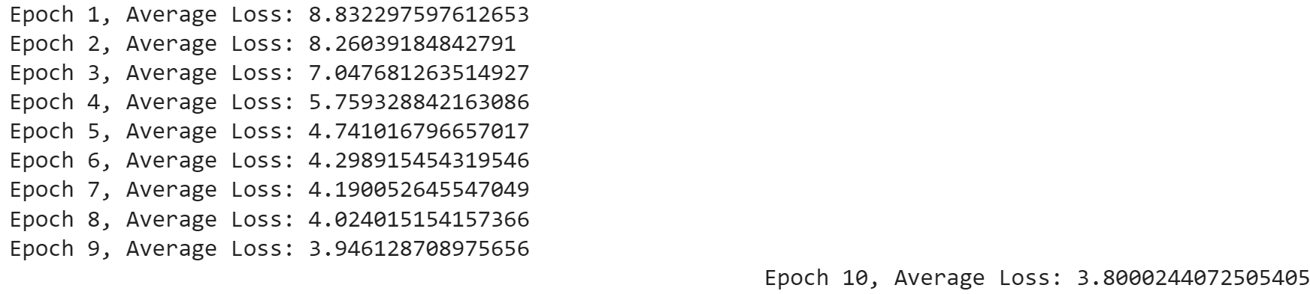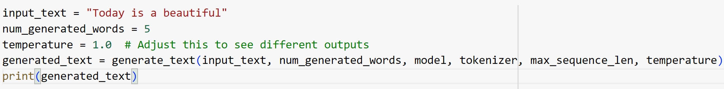Today is a beautiful life at uji was very dull now that the trip to ishiyama was off. he wrote her a letter full of the most earnest assurances, but it was a worry just to send it. he had it delivered by a retainer of tokikata, one who did not know what the issue was. “a gentleman i used to know came here among his lordship's escort and rediscovered me, and now he is courting me again,” ukon explained to the other women. yes, by now she had a lie for every occasion. “oh, it was dreadful, dreadful, and for many reasons i detest living on and on this way, ever the same, when either misfortune shows how little this world is to be trusted; and yet i know very well from the joy of seeing you come into your own again how sorry i would have been to know no more of you after those years.” she began to tremble. “what a splendid-looking man you are now! when i first knew you, as a boy, i wondered that so bright a light should have come into the world, and i feared for you after that whenever i saw you. people tell me his majesty is very like you, but i cannot believe he really compares with you!”

Repeated sentence found: he wrote her a letter full of the most earnest assurances but it was a worry just to send it

repeated_text_overall_percent: 0.08340888485947416 %

In a certain reign (whose can it have been?) someone of no very great rank, among all His Majesty's Consorts and Intimates, enjoyed exceptional favor. “the insight that the world is dross, hence the first thoughts of hatred for it, generally follows from personal unhappiness, for it is at such times that one rejects the world and conceives the aspiration to higher things; and it is remarkable to hear of so fortunate a young man, who presumably lacks nothing that he might desire, being so preoccupied by the life to come. i suppose that i myself was destined to take this path, since it was as though the buddha himself urged me to shun the world, and in due course i had my wish for peace and quiet. still, i doubt that i have much time left now, and considering how approximate my mode of life really is and how little likely i am ever fully to understand the past or the future, he will be a friend in the teaching before whom i should properly feel deficient.” he talked on like this for some time, and after an exchange of letters the young man himself arrived. “the name of this place means what it has always meant, yet the love i knew genji smiled. “you have sharp ears after all, and for me the autumn wind blows more cuttingly than ever." he pushed the instrument away. she was extremely put out.

Repeated sentence found: i suppose that i myself was destined to take this path since it was as though the buddha himself urged me to shun the world and in due course i had my wish for peace and quiet

repeated_text_overall_percent: 0.13358778625954199 %

In a certain reign (whose can it have been?) someone of no very great rank, among all His Majesty's Consorts and Intimates, enjoyed exceptional favor. “there is a screen on the other side,” the thoughtless young woman replied. “he could not peek through so soon!” why did i have to go and say all that? he asked himself ruefully, wondering at the same time when he would ever see again, even through curtains and blinds, a figure now more than ever sharply graven in his mind, or hear that voice however faintly. he reached genji's residence preoccupied by these unhappy thoughts. genji came forth, and he gave him her reply. eager to test his new teeth, the boy clutched a bamboo shoot and mouthed it, drooling. “he certainly has an odd idea of gallantry!” genji remarked. news of these preparations reached his excellency the palace minister from afar and left him at once intensely worried and bitterly disappointed. his daughter was now in full flower and too pretty to waste. he hated to see her bored and dispirited, but that young man of hers remained as serene as ever, and he would look silly if he meekly approached him himself. no, he groaned, if only i had let myself be persuaded when he was so obviously keen on her! he could not blame just the young man. the consultant captain heard that he had softened his attitude some-what, but he was still so angry about the rude way he had once been treated that he pretended not to care, and although he often felt in no mood for laughter, since in fact he had no interest in anyone else, her nurse's gibes about that light blue of his only confirmed his resolve to have them see him rise to counselor first. “there was such a beautiful moon last night that we regretted not coming with you, and this morning we made our way here through the mists. the colors in the fields were lovely, though it is still too early for brocade on the hills."

Repeated sentence found: he reached genjis residence preoccupied by these unhappy thoughts

repeated_text_overall_percent: 0.034228541337546076 %

In a certain reign (whose can it have been?) someone of no very great rank, among all His Majesty's Consorts and Intimates, enjoyed exceptional favor. “for some years now i have inhabited the same world as you and yet felt somehow quite different from before, which is why i have neither written, except as necessary, nor sought to learn your news. letters in kana take me time to read, and moments spent otherwise than calling the name are moments lost. that is why i have sent you nothing. i gather that your daughter is now with the heir apparent and that she has borne him a son. that is a very great joy. i say that because although i am only a mountain ascetic and desire no worldly glory, i must confess that i have for many years thought of nothing but you, even during my day and night devotions, and that my prayers have been for you, to the neglect of any longing of mine for the dew on the lotus. these autumn leaves from my home, carried to you on the wind.” “o seer who roams the vastness of the heavens, go and find for me he spent a day filled with memories reproaching her for refusing to forgive him, and after that he could not go there again. instead he sent a note to the main house: “the snow this morning left me feeling too unwell, and i am lazily enjoying the comforts of home.” his highness had never paid any particular attention to jijū before, but the intimacy of their shared grief moved him to say, “come into service here! it is not as though you were nothing to her highness.”

Repeated sentence found: letters in kana take me time to read and moments spent otherwise than calling the name are moments lost

repeated_text_overall_percent: 0.0682571239231279 %